MONDAY | TUESDAY | WEDNESDAY | THURSDAY | FRIDAY
1

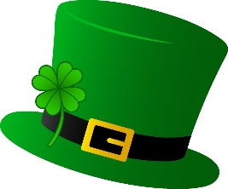

4 BREAKFAST  Pancake Wraps  Fruit/Juice  LUNCH  Corn Dogs  Tater Tots  Green Beans  Fruit | 5 BREAKFAST  Cereal  Toast  Fruit/Juice  LUNCH  Chicken Alfredo  Peas  Fruit | 6 BREAKFAST  Hard Boiled Eggs  Toast  Fruit/Juice  LUNCH  Pulled Pork  Beans  Fruit | 7 BREAKFAST  Bagels  Fruit Smoothies  LUNCH  Field Trip | 8 BREAKFAST  Oatmeal  Toast  Fruit/Juice  LUNCH  Tomato Soup  Grilled Cheese  Fruit
11 BREAKFAST  Waffles  Fruit/Juice  LUNCH  Hamburgers  French Fries  Green Beans  Fruit | 12 BREAKFAST  Cereal  Toast  Fruit/Juice  LUNCH  Chicken Bacon Wraps  Corn  Fruit | 13 BREAKFAST  Cheese Omelets  Toast  Fruit/Juice  LUNCH  Beef Stroganoff  Squash  Fruit | 14 BREAKFAST  Muffins  Yogurt  Fruit/Juice  LUNCH  Chicken Burger  Hashbrowns  Peas  Fruit | 15 
18 BREAKFAST  Pancakes  Fruit/Juice  LUNCH  Orange Chicken  Fried Rice  Peas  Fruit | 19 BREAKFAST  Cereal  Toast  Fruit/Juice  LUNCH  BBQ  Green Beans  Hashbrowns  Fruit | 20 BREAKFAST  Egg Bake  Toast  Fruit/Juice  LUNCH  Knoephla Soup  Sandwiches  Fruit | 21 BREAKFAST  Bagels  Fruit Smoothies  LUNCH  Turkey  Mashed Potatoes  Stuffing  Buns  Creamed Corn | 22 BREAKFAST  Scrambled Eggs  Toast  Fruit/Juice  LUNCH  Tomato Soup  Grilled Cheese  Fruit
25 BREAKFAST  French Toast  Fruit/Juice  LUNCH  Meatballs  Mashed Potatoes  Corn  Fruit | 26 BREAKFAST  Cereal  Toast  Fruit/Juice  LUNCH  Chicken Nuggets  Rotini  Peas  Fruit | 27 BREAKFAST  Egg Muffin  Toast  Fruit/Juice  LUNCH  Pulled Pork  Beans  Fruit | 28  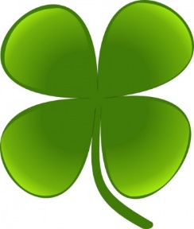 | 29  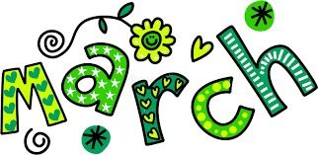
In accordance with federal civil rights law and U.S. Department of Agriculture (USDA) civil rights regulations and policies, this institution is prohibited from discriminating on the basis of race, color, national origin, sex (including gender identity and sexual orientation), disability, age, or reprisal or retaliation for prior civil rights activity.

